Setting Up Network Load Balancing

Step 1. Installing and configure the Windows 2019 Servers

This is already done as I am using Proxmox.

Step 2: Removing duplicate SID. You navigate to a directory having sysprep.exe application. Run it and then restart the server.

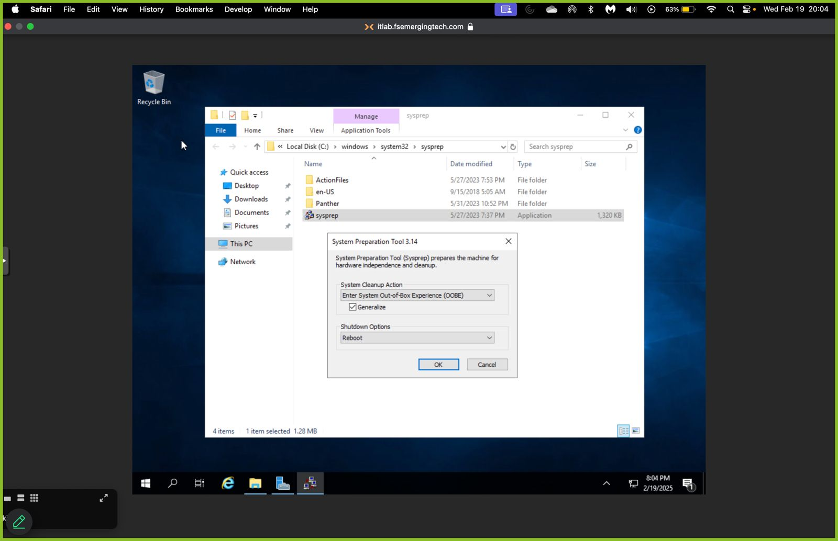

Step 3: Generating a new SID, Naming the servers.

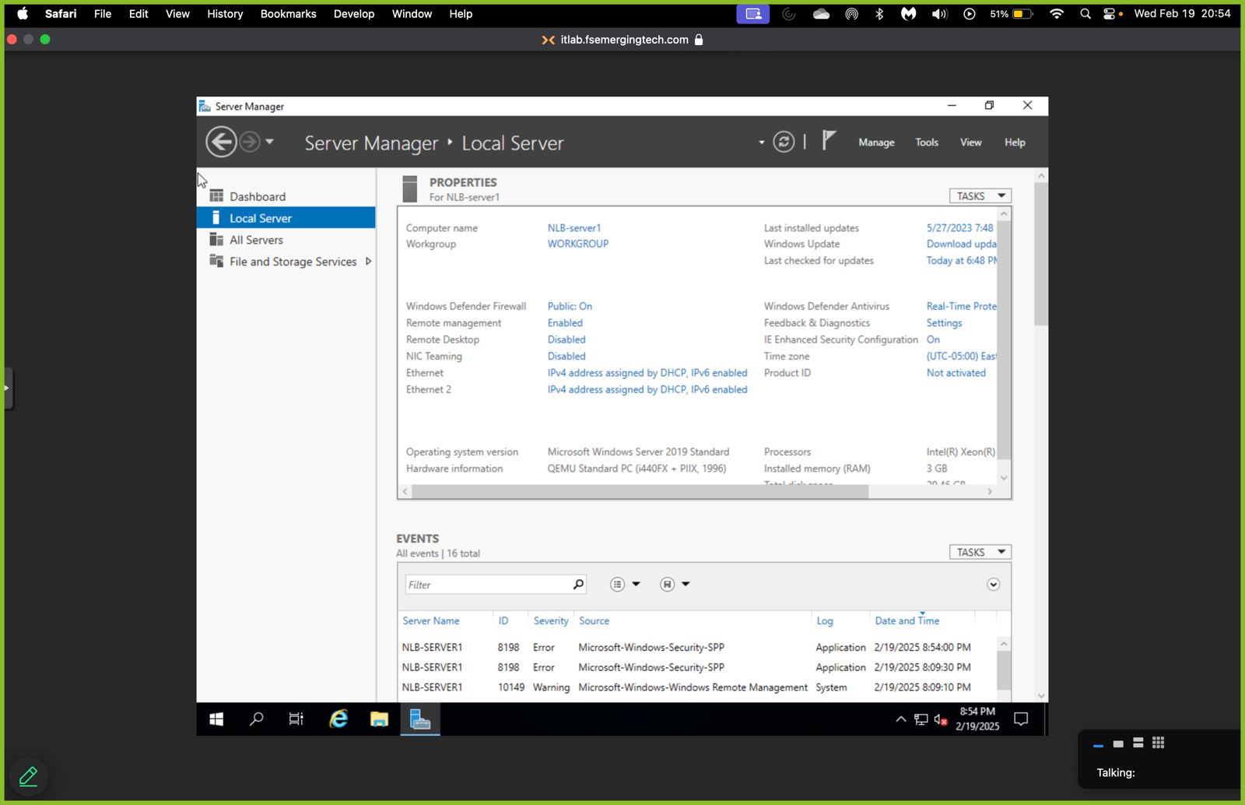Server 1:NLB-server1

Server 2: NLB-server2

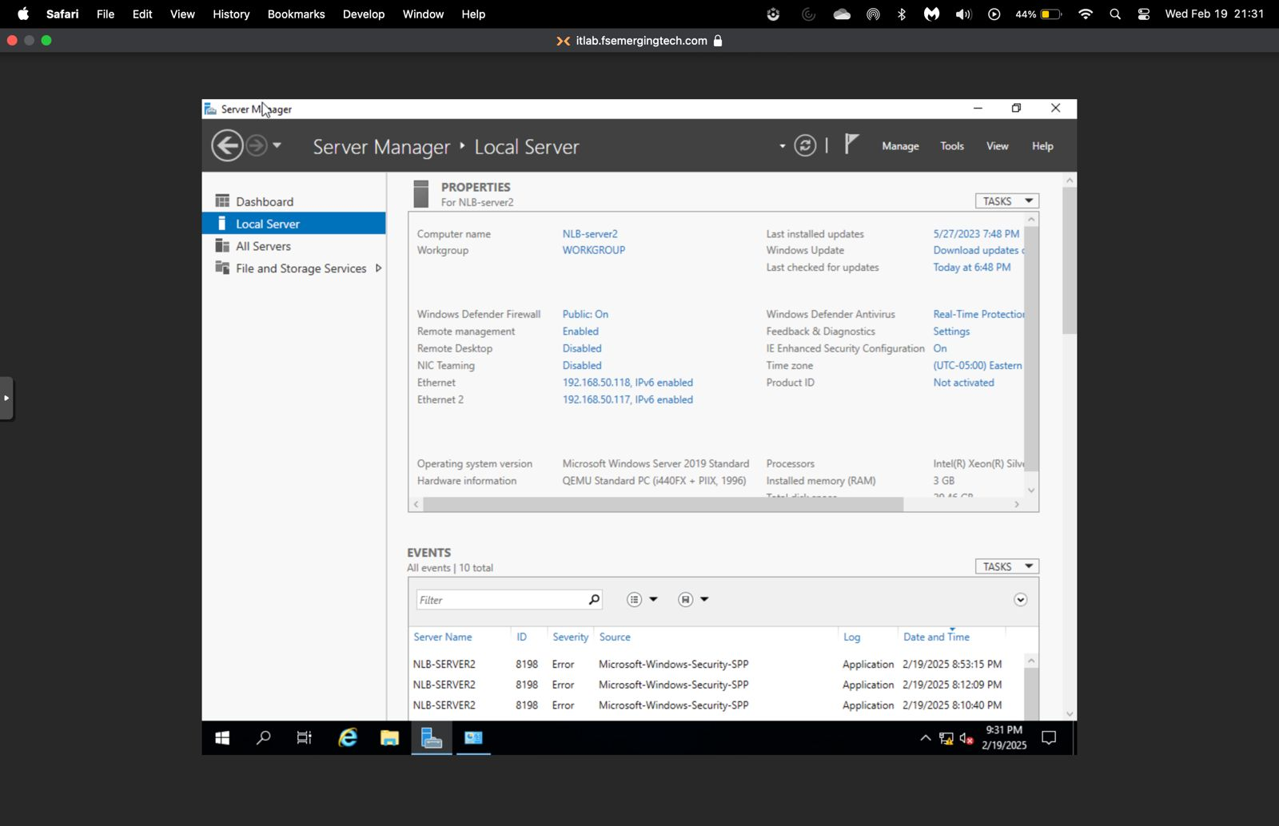

Step 4: Each server having 2 NICs and 2 static IP addresses

NLB-server1

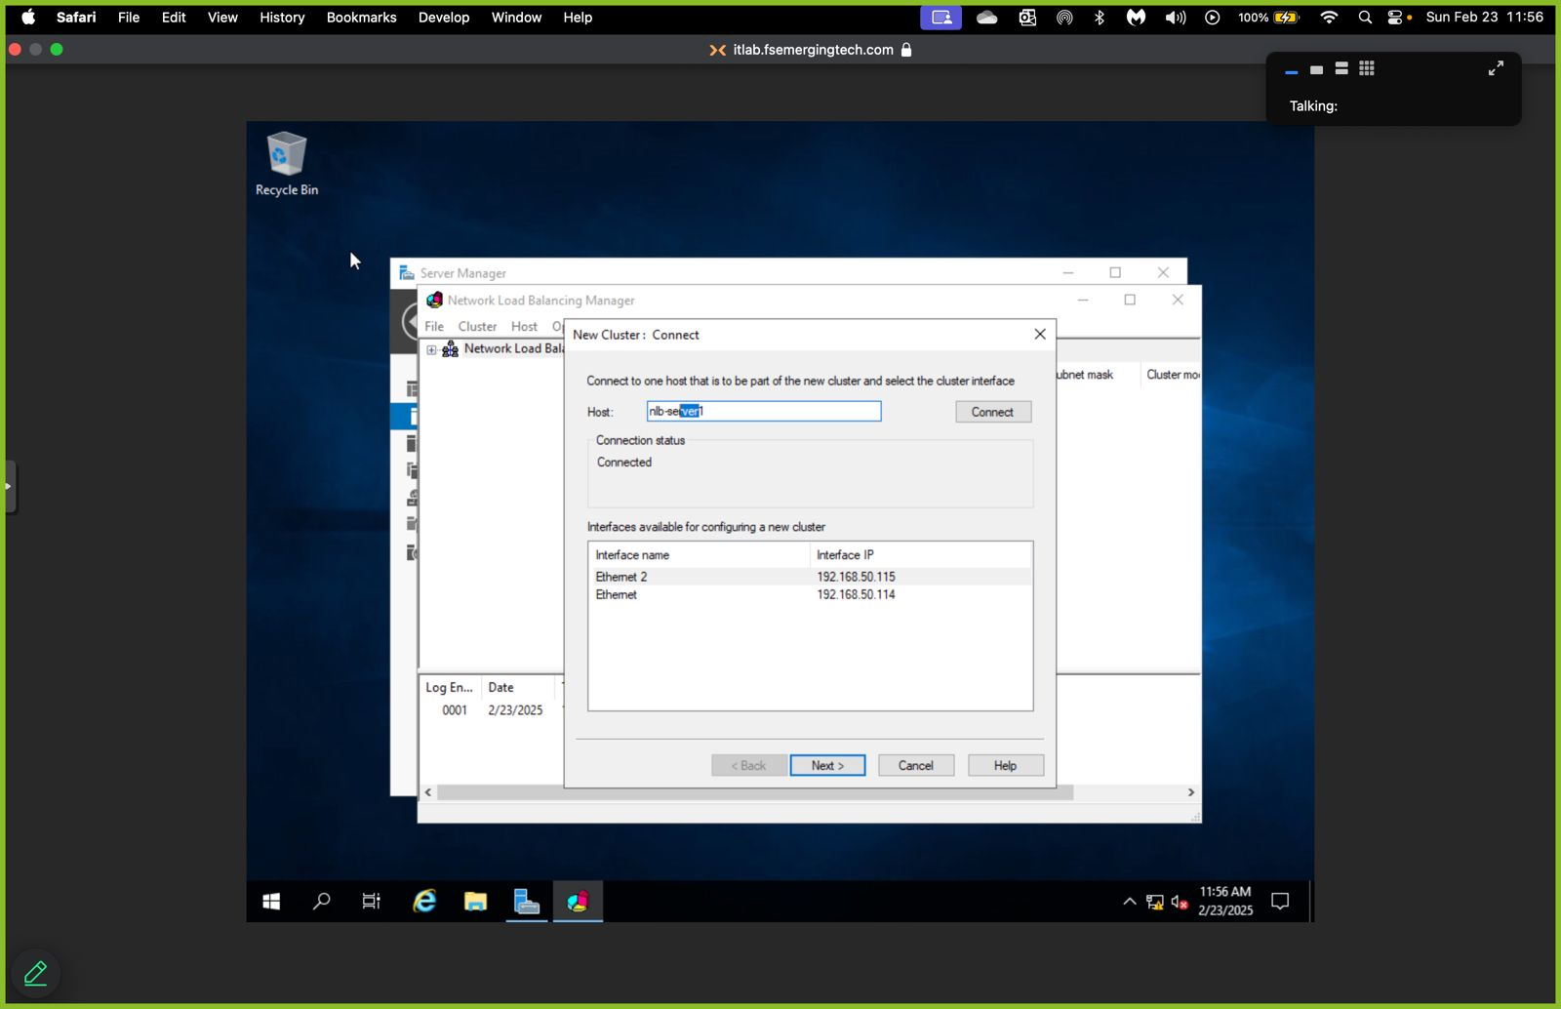

NLB-server2:

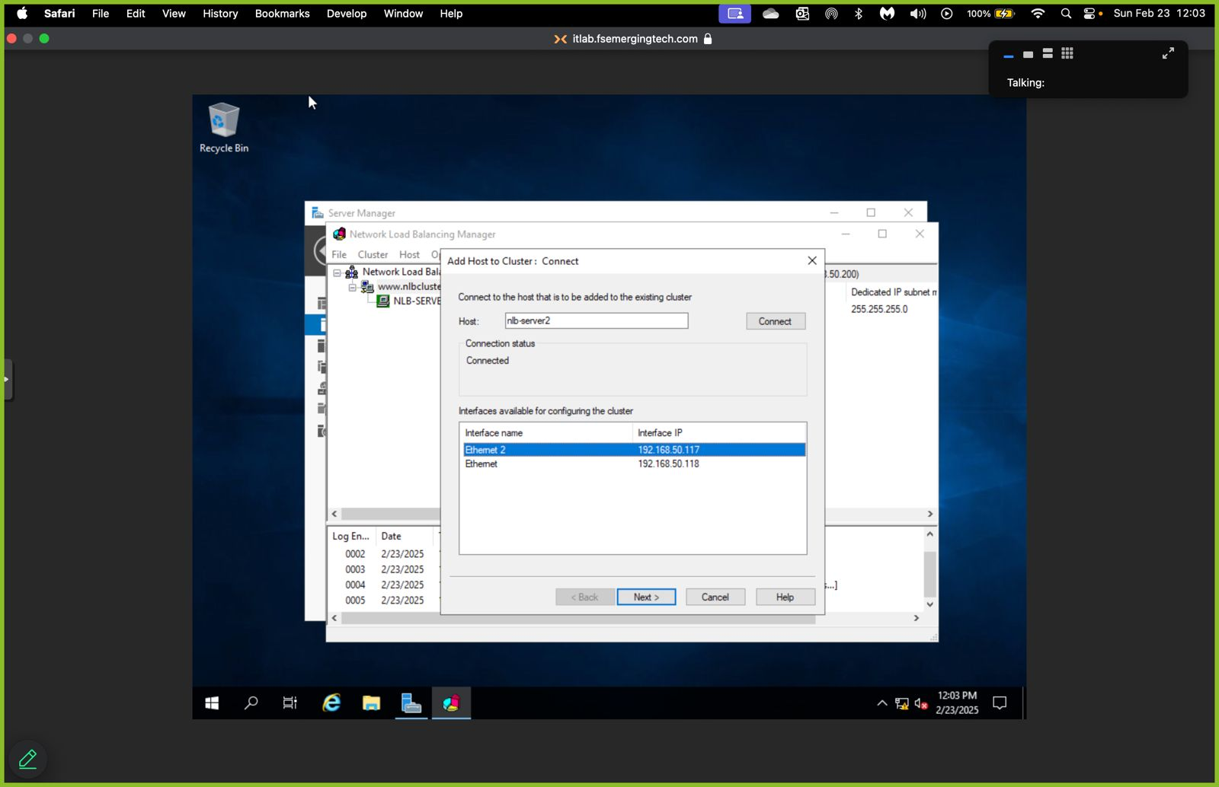

Step 5: Installing IIS. Both are the same process for the two servers.

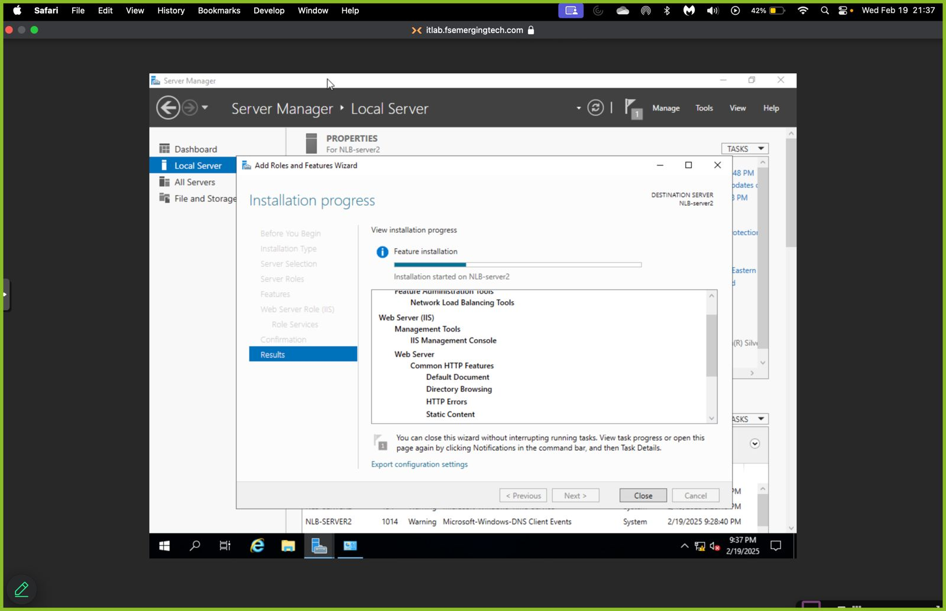

Step 6

